**Name: PARMESH YADAV**

**Roll No: 2020319**

MTH-372 SI

ASSIGNMENT- 1

**QUESTION – 1**

**Exponential(λ).**

1. Simulate random sample of size 1000 from Exponential (λ). Use λ = 1, 2, 3, 4.

To simulate the above random variable, I have used rexp() function which takes sample size and λ as argument and returns a sample set.

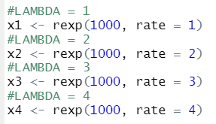 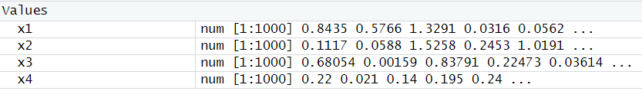

1. For all the above-mentioned values of λ, find the maximum likelihood estimate of the unknown parameter in R. Show the results by using three different sets of initial values, one of them would be the estimates obtained using method of moments.

As mentioned in the question, one of the sets have to be the estimates obtained by using MOM (method of moments). Therefore, using MOM:

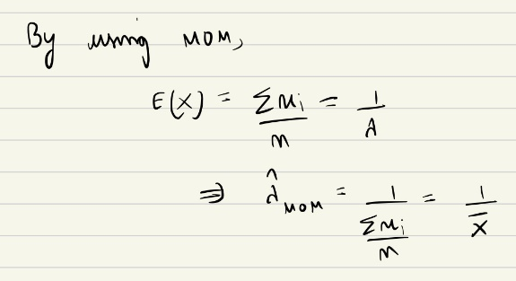

Hence, using MOM the estimates for λ in exponential distribution comes out to be

λ = 1/(mean(X)); X being the sample data

Therefore, we calculate the MOM estimates:

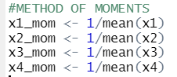

Now we create 3 sets of initial values from which MLE is to be calculated, the first set will comprise of MOM estimated as according to the question:

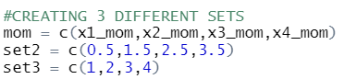

Now we create the likelihood function, or in this case a negative likelihood function as later to calculate the MLE we have to use the optim() function which minimizes any given function. So, maximization of log likelihood function is same as minimization of negative log likelihood function.

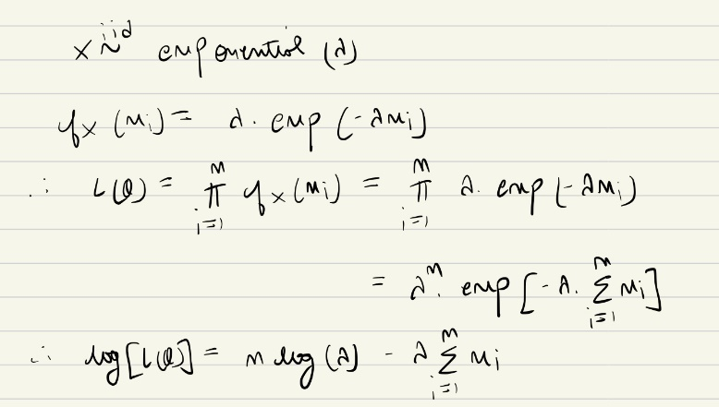

Then MLE can be calculated using the optim() function for all 4 sample sets, using 3 sets of initial values for each sample.

1. Verify the results graphically and make a comparison for above mentioned values of λ.

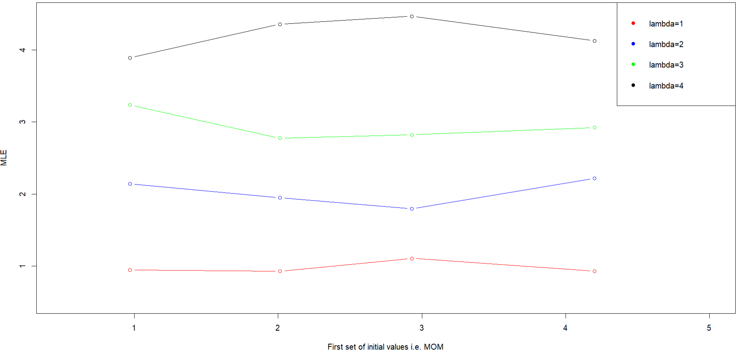

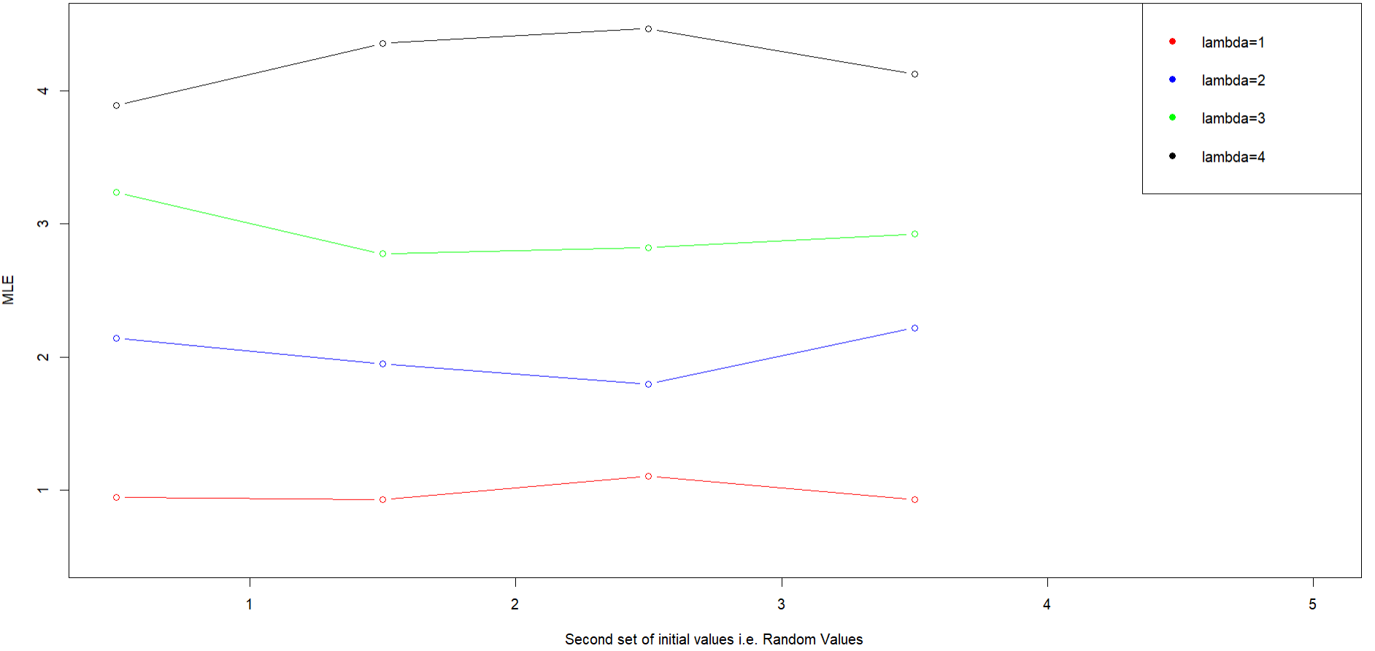

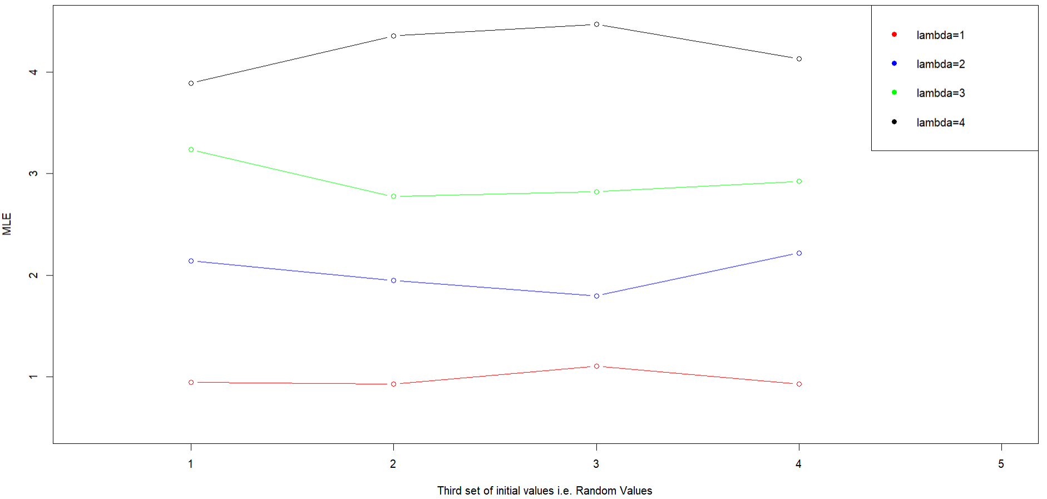

We can clearly see from the above graphs that the estimates calculated by using MLE (maximum likelihood estimation) are almost equal to their actual value i.e., λ = 1,2,3,4.

Also, an interesting inference is that the MLE estimates are best when the initial value is equal to the actual value.

**QUESTION – 2**

**Data of birth weight (in grams) of new-born babies follows Normal** **(μ, σ2)**

1. Using R, write a function to obtain the maximum likelihood estimate of the parameters.

Similar to the previous question, we first define the log likelihood function and then use the optim() function calculate the MLE of the parameters.\

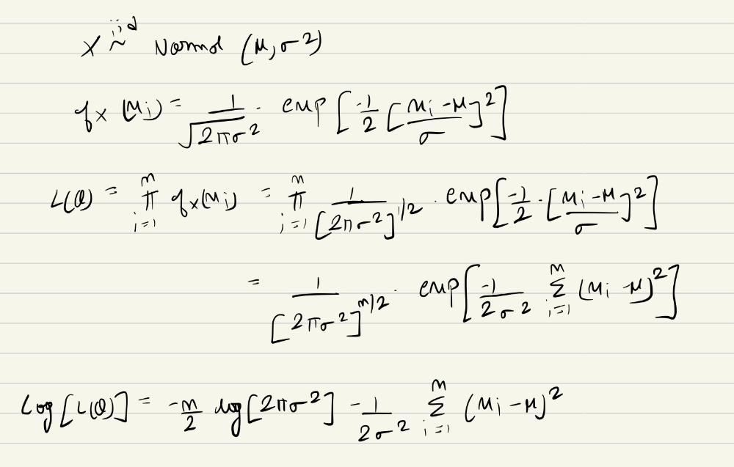

1. Considering one parameter as known, show graphically that the likelihood function attains maxima at the above estimate. (Hint: For one of the parameters use MLE value. Then for various values of another parameter plot the likelihood function.)

As given in the question, I took the value of mean as known (MLE value) and calculated likelihood function for a range of values for standard deviation/variance.

Here is the output of this:

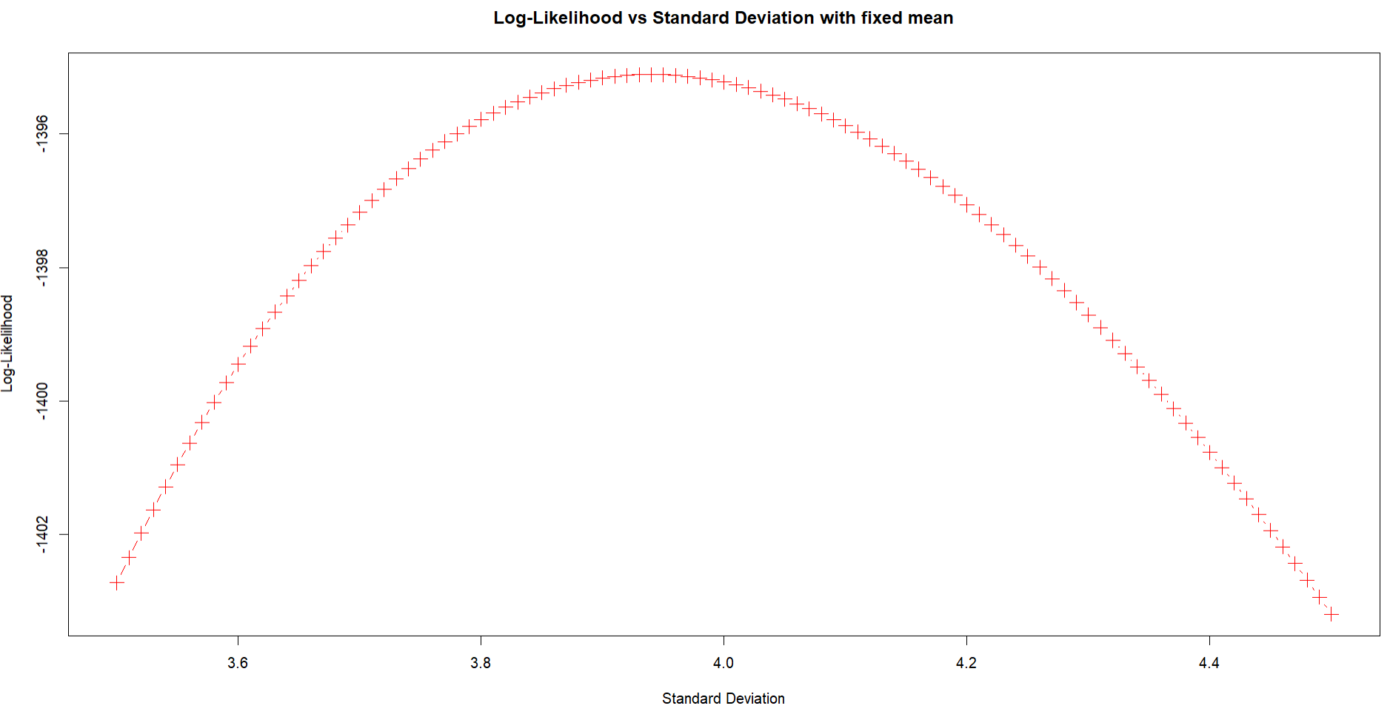

Here, we can clearly infer that the likelihood function attains maxima at the estimates calculated in the previous parts.

